

DEPARTMENT OF COMPUTER SCIENCE AND BUSINESS SYSTEMS

Academic Year
2022 – 2023 (Odd Semester)

MINI PROJECT REPORT

U19CS202 Database Management Systems
&
U19CS203 Object-Oriented Programming

------ Automatic Ticket Vending Machine -----

Submitted by, Mentored by,
[21CB013] | Hariharan M
[21CB014] | Hemanth M
[21CB016] | Kamesh A
[21CB021] | Maduvant SP
Mrs. Priyanka Gandhi
Assistant Professor,
Department of CSBS

 | TABLE OF CONTENTS
CHAPTER NO. | TITLE |  |  |  | PAGE NO.
 | ABSTRACT |  |  |  | i
1 | INTRODUCTION |  |  |  | 4
 | 1.1 |  | OBJECTIVES |  | 4
 | 1.2 |  | SCOPE OF THE PROJECT |  | 4
2 | SYSTEM ANALYSIS AND SPECIFICATION |  |  |  | 5
 | 2.1 |  | PROBLEM DESCRIPTION |  | 5
 | 2.2 |  | FRONT END |  | 5
 | 2.3 |  | BACK-END |  | 5
3 | SYSTEM DESIGN |  |  |  | 6
 | 3.1 |  | ER DIAGRAM |  | 6
 | 3.2 |  | SCHEMA DIAGRAM |  | 7
4 | PROPOSED SOLUTION |  |  |  | 8
 | 4.1 OVERVIEW |  | USER INTERFACE DESIGN |  | 8
 | 4.2 |  | CLASS CONSTRUCTION |  | 8
 | 4.3 |  | DATABASE CREATION |  | 9
5 |  | PROJECT DESCRIPTION |  |  |  | 9
 |  | 5.1 |  | Modules |  | 9
 |  |  |  | 5.1.1 |  | 9
 |  |  |  | 5.1.2 |  | 9
 |  |  |  | 5.1.3 |  | 9
 |  | 5.2 |  | JDBC CONNECTIVITY |  | 10
6 |  | IMPLEMENTATION |  |  |  | 10
7 |  | RESULTS AND DISCUSSION |  |  |  | 18
8 |  | CONCLUSION & FUTURE ENHANCEMENT |  |  |  | 18
 |  | REFERENCES |  |  |  | 19

ABSTRACT

An automatic ticket vending machine is a machine that allows customers to purchase tickets for transportation or events without the need for a human clerk. These machines are often found at train stations, bus terminals, and other places where tickets are sold. The project aims to design and implement a fully-automated ticket vending machine that can be used by customers to quickly and easily purchase tickets. The machine will use a user-friendly interface and will accept various forms of payment, including cash, credit cards, and debit cards. The goal is to create a convenient and efficient way for customers to purchase tickets, while also reducing the need for human labor. In this project, We are building a software for Automatic ticket vending machine.

CHAPTER 1
INTRODUCTION

  - OBJECTIVES
- ATVM – Automatic Ticket Vending Machine is a software created for the purpose of booking train ticket as well as platform tickets using smart card.
- In this machine, we can find the relevant results of train details as per the user’s need and book the tickets and make payments using modern technologies such as smartcards and QR codes.
- For recharging the smartcard, people have to go to the railway station booking counters and top-up the cards.
  - SCOPE OF THE PROJECT
    - With the help of Automatic Vending Machine, people can save their time i.e instead of waiting in line for tickets, they can just simply use the smartcard for ticket booking.
    - The users can not only book tickets but can also find the required train routes, their arrival and departure, the distance between the boarding destination and even book platform tickets..
    - In today’s lifestyle where everything is digitalized, there is no need for the user to carry the exact change needed for the tickets as they can use our smart card and we provide further option like QR code scanning.

CHAPTER 2
SYSTEM ANALYSIS AND SPECIFICATION

2.1 PROBLEM DESCRIPTION
In traditional method of train ticket booking, people face issues like long and tiring queues and payment problems . Further, in some stations there are limited booking counters like only one or two booking counters and also the people who are working in the ticket counter are not always available. Once after purchasing and recharging the smartcard, there no need to stand in queue to get tickets for every travel.

2.2 FRONT END
- Processor Type : Core i3
- Speed : 3.40GHZ
- RAM : 4GB DD2 RAM
- Hard disk : 500 GB

2.3 BACK END
- MySQL Libraries
- MySQL Workbench
- Eclipse IDE Apache Tomcat Server
- Operating system : Windows10

CHAPTER 3
SYSTEM DESIGN

3.1 ER DIAGRAM

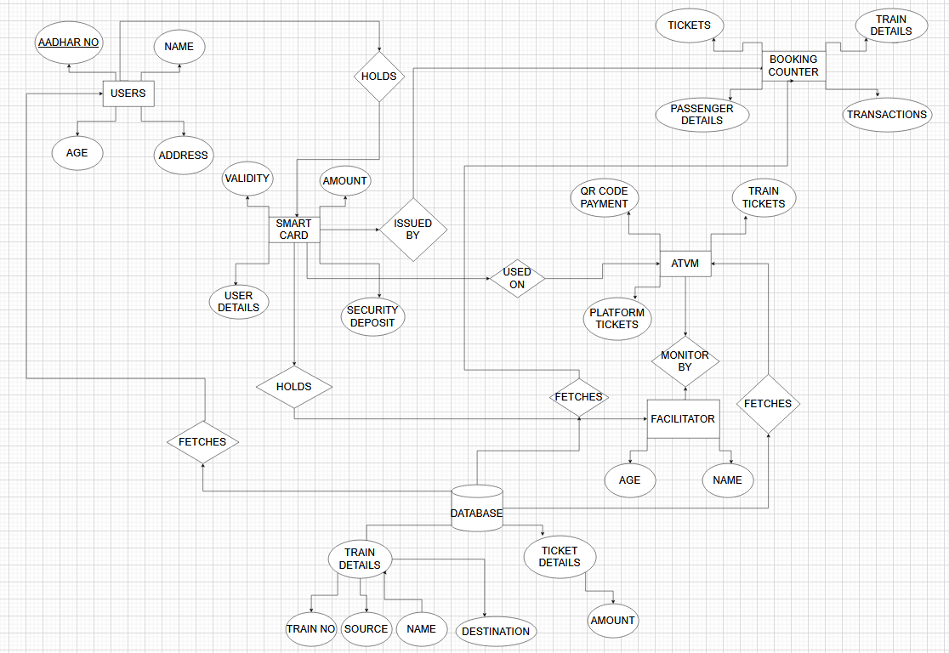

3.2 SCHEMA DIAGRAM

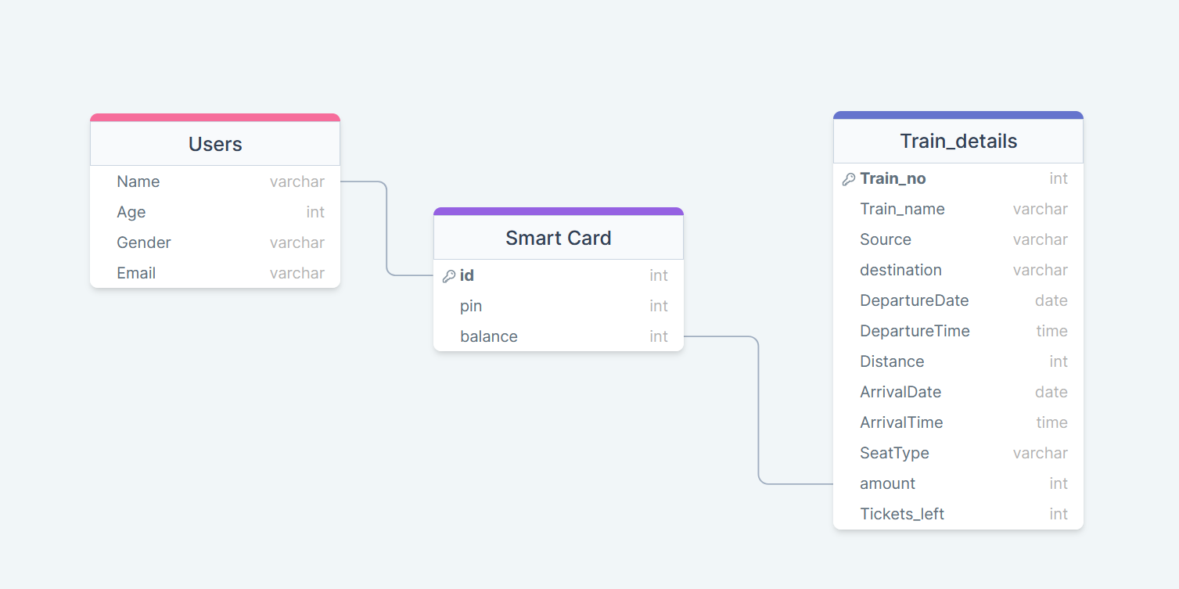

CHAPTER 4
PROPOSED SOLUTION

4.1 USER INTERFACE DESIGN
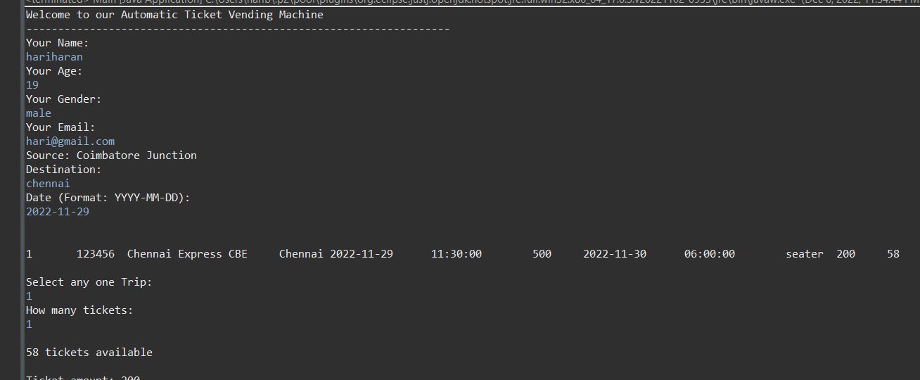

For testing purpose, we are providing the output of the project in JAVA console. When we implement this project in original ATVM, we will use HTML, CSS and React JS to make the User Interface more user friendly and reliable.

4.2 CLASS CONSTRUCTION
In this project, we used only one class with two methods. One of the methods is to check train details and booking and the another method is to pay through smartcard.

4.3 DATABASE CREATION
We have created one database with three tables; one table to store user information, second table to store the train details and the third table to store the smart card information. Here we used MySQL to create database.

CHAPTER 5
PROJECT DESCRIPTION

5.1 MODULE DESCRIPTION
5.1.1 Booking Module – Here we are providing the train details according to the users’ needs and wants.
5.1.2 Payment Module – In this module, we are using smart card and QR code scanning option in this module to make the payments for the ticket booking process.
5.1.3 User Module - In this module we are collecting information from the user i.e., the basic information like the name, gender, age.

5.2 JDBC CONNECTIVITY

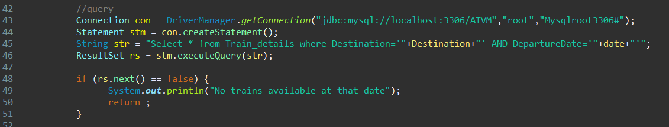

- First, we have to install mysql-connector.jar file.
- Then, we have to add the jar file in our projects’ referenced libraries.
- Now we have to add the above-mentioned code in the name.java file.
- By this we can connect the database using JDBC.

CHAPTER 6
IMPLEMENTATION

import java.sql.*;
import java.util.*;
import javax.mail.*;
import javax.mail.internet.*;

public class Main {

public static void main(String[] args) {
try (Scanner sc = new Scanner(System.in)) {
// Class.forName("com.mysql.jdbc.Driver");
try {

String emailRegex = "^[a-zA-Z0-9_+&*-]+(?:\\." + "[a-zA-Z0-9_+&*-]+)*@" + "(?:[a-zA-Z0-9-]+\\.)+[a-z" + "A-Z]{2,7}$";
System.out.println("Welcome to our Automatic Ticket Vending Machine\n-------------------------------------------------------------------");

//user details
System.out.println("Your Name: ");
String Name = sc.nextLine();
System.out.println("Your Age: ");
int age = sc.nextInt();
sc.nextLine();
System.out.println("Your Gender: ");
String Gender = sc.nextLine();
int emailvalid = 0;
System.out.println("Your Email: ");
String email = sc.nextLine();
if(!email.matches(emailRegex)) {
System.out.println("Entered email is wrong");
}
else {emailvalid = 1;}

//get destination & date to make query
System.out.println("Source: Coimbatore Junction");
System.out.println("Destination: ");
String Destination = sc.nextLine();
System.out.println("Date (Format: YYYY-MM-DD): ");
String date = sc.nextLine();

System.out.println("\n");

//query
Connection con = DriverManager.getConnection("jdbc:mysql://localhost:3306/ATVM","root","Mysqlroot3306#");
Statement stm = con.createStatement();
String str = "Select * from Train_details where Destination='"+Destination+"' AND DepartureDate='"+date+"'";
ResultSet rs = stm.executeQuery(str);

if (rs.next() == false) {
System.out.println("No trains available at that date");
return ;
}

do {
System.out.println(rs.getString(1)+"\t"+rs.getString(2)+"\t"+rs.getString(3)+"\t"+rs.getString(4)+"\t"+rs.getString(5)+"\t"+rs.getString(6)+"\t"+rs.getString(7)+"\t"+rs.getString(8)+"\t"+rs.getString(9)+"\t"+rs.getString(10)+"\t"+rs.getString(11)+"\t"+rs.getString(12)+"\t"+rs.getString(13));
}while(rs.next());
//Select any train
System.out.println("\nSelect any one Trip: ");
int sno = sc.nextInt();

//check tickets availability
String str2 = "Select Tickets_left from Train_details where SNo="+sno;
ResultSet rs2 = stm.executeQuery(str2);
System.out.println("How many tickets: ");
int Ticket_need = sc.nextInt();
while(rs2.next()) {
int tickets = rs2.getInt(1);
if(tickets == 0 || tickets<Ticket_need) {
System.out.println("\nTickets Insufficient");
return ;
}
else {
System.out.println("\n"+tickets+" tickets available\n");
}
}

//get amount
String str3 = "Select Amount from Train_details where Sno="+sno;
ResultSet rs3 = stm.executeQuery(str3);
while(rs3.next()) {
int amount = rs3.getInt(1);
int platform = 10;
int Total = (Ticket_need*amount) + (Ticket_need*platform);
System.out.println("Ticket amount: "+(Ticket_need*amount)+"\nPlatform ticket: "+(Ticket_need*platform)+"\nTotal: "+Total);

//Payment through
System.out.println("\nPayment through\n1. Smart Card\n2. QR code");
System.out.println("Choose a option: ");
int option = sc.nextInt();
switch(option) {
case 1:
Smartcard(Total);
break;
case 2:
System.out.println("Under development");
break;
default:
System.out.println("Choose valid option");
}
}

//ticket update
String str5 = "Select Tickets_left from Train_details where SNo="+sno;
ResultSet rs5 = stm.executeQuery(str5);
rs5.next();
int tickets = rs5.getInt(1);
tickets = tickets - Ticket_need;
String str4 = "UPDATE Train_details SET Tickets_left="+tickets+" where SNo="+sno;
stm.executeUpdate(str4);

// tickets = tickets - Ticket_need;
// String str4 = "UPDATE Train_details SET tickets="+tickets+" where SNo="+sno;
// stm.executeUpdate(str4);
// while(rs4.next()) {
// int tickets = rs4.getInt(1);
// tickets = tickets-Ticket_need;
// String updation = "UPDATE Train_details SET tickets="+tickets+" where SNo="+sno;
// stm.execute(updation);
// }

}
catch(Exception e) {
System.out.println(e);
}
}
}
static void Smartcard(int Total) {
Scanner sc = new Scanner(System.in);
System.out.println("\nYour Smart card id:");
String id = sc.nextLine();

//check smartcard existence
try {
Connection con = DriverManager.getConnection("jdbc:mysql://localhost:3306/ATVM","root","Mysqlroot3306#");
Statement stm = con.createStatement();
String str = "Select * from smartcard where ID='"+id+"'";
ResultSet rs = stm.executeQuery(str);
if(rs.next()==false) {
System.out.println("No smartcard detail is available");
return;
}
else {System.out.println("\nhello "+rs.getString("Name")+"! Your Smartcard details available");}

//security Authentication
String str1 = "Select pin from smartcard where ID='"+id+"'";
ResultSet rs1 = stm.executeQuery(str1);
rs1.next();
int originalpin = rs1.getInt("pin");
System.out.println("Enter pin:");
int userpin = sc.nextInt();
if(originalpin == userpin)
{
System.out.println("\nPin is correct");
}
else {System.out.println("\nPin is wrong"); return;}
//get Balance
String str2 = "Select Balance from smartcard where ID='"+id+"'";
ResultSet rs2 = stm.executeQuery(str2);
while(rs2.next()) {
int Balance = rs2.getInt(1);
if(Balance <= 50) {
System.out.println("\nBalance Amount is lower than minimum balance: "+Balance);
return;
}
if(Balance <= Total+50) {
System.out.println("Low Balance");
return;
}
Balance = Balance - Total;
String updation = "UPDATE smartcard SET Balance="+Balance+" where id="+id;
stm.execute(updation);
System.out.println("Your Balance is: "+Balance);
System.out.println("Your ticket is booked. Check your mail");
}
}
catch(Exception e) {}
sc.close();
}
}

CHAPTER 7
RESULTS AND DISCUSSIONS

RESULT:

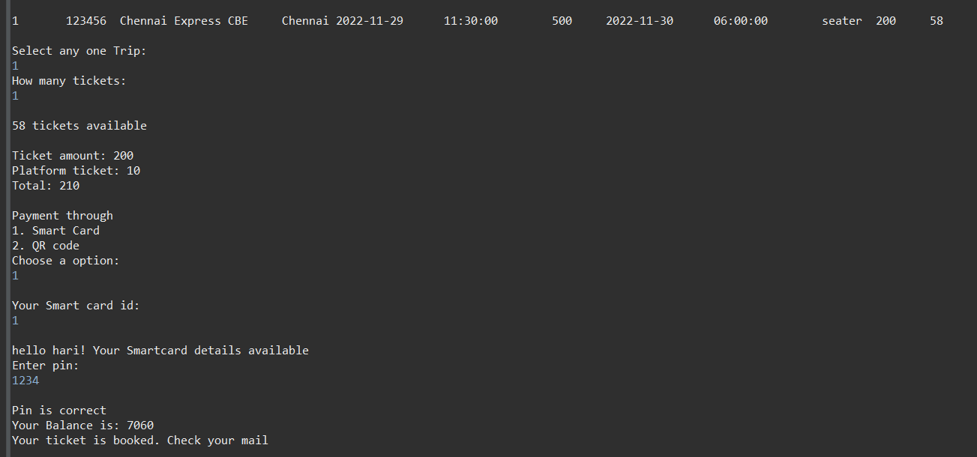

DESCRIPTION:
This is the output of our project. We successfully searched for a train and successfully booked our ticket using ATVM and paid through our smart card. The data is modified and updated in the database.

CHAPTER 8
CONCLUSION AND FUTURE ENHANCEMENT
To conclude, our Automatic Ticket Vending Machine will be of great use to the people and the railway station staffs on a regular basis and saves time too. In future there will be more ATVMs in every station and the payment method for which will be more reliable and further reservation options for train tickets will be developed and made available to people.

REFERENCES

[1] https://youtu.be/5vzCjvUwMXg

